User Port/Parallel Adapter for Commodore 1541/1541-II Rev. 0

Module Description

# Introduction

Some speed-loaders for the C64 make use of a parallel data transfer for communicating with the Commodore 1541 or 1541-II floppy disk drive. This is possible, because in both FDDs a complete port (PAx) and two hand shake pins (CA2, CB1) of the 2nd VIA (6522) are not used.

SpeedDOS utilizes this fact and uses a ribbon cable between the VIA and the User Port.

Very often, the ribbon cable has been attached to an extra DIP40 socket, which it is soldered to, that fits between the original socket and the VIA. This ribbon cable is then connected to an edge connector for the user port. This is a cheap solution, which is not very reliable. A wire can be torn off the socket or the ribbon cable gets old and brittle etc.

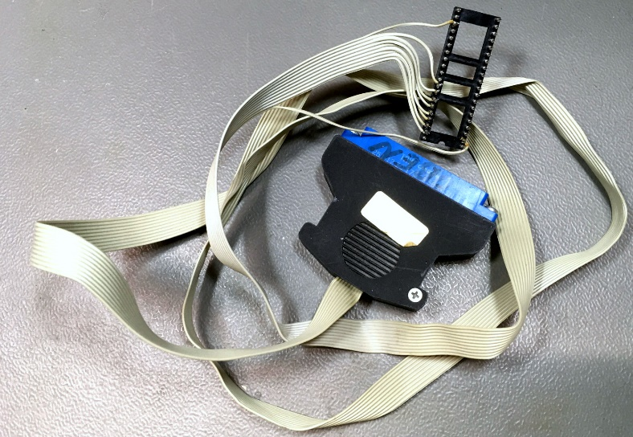

Figure 1: Traditional Parallel Cable

The User Port Adapter provides a solution with an easy to make and easy to replace cable. The risk of a wrong assembly is little. It works in conjunction with a dedicated VIA adapter for the 1541 and a low-profile adapter for the 1541-II.

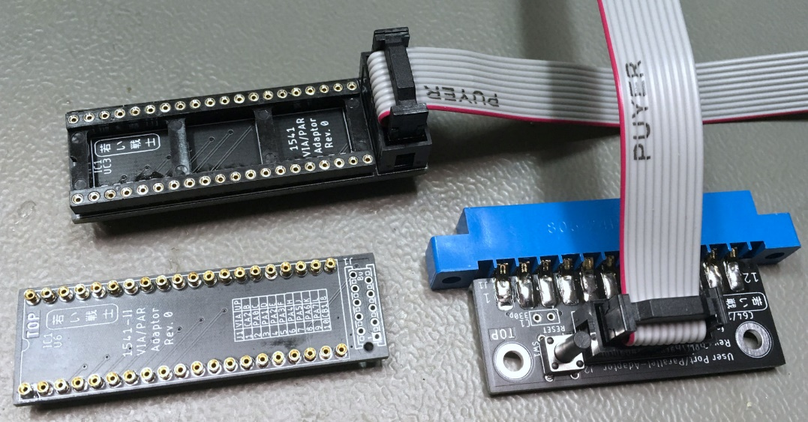

Figure 2: User Port Parallel Adapter and both sorts of VIA Adapters

The connections between the user port and the VIA for SpeedDOS are defined like this:

|  |  |  |  |  |  |
| --- | --- | --- | --- | --- | --- |
| **UP (pin)** | **VIA (pin)** | **J2** | **J2** | **VIA (pin)** | **UP (pin)** |
| (B) | CA2 (39) | 1 | 2 | PA0 (2) | PB0 (C) |
| PB1 (D) | PA1 (3) | 3 | 4 | PA2 (4) | PB2 (E) |
| PB3 (F) | PA3 (5) | 5 | 6 | PA4 (6) | PB4 (H) |
| PB5 (J) | PA5 (7) | 7 | 8 | PA6 (8) | PB6 (K) |
| PB7 (L) | PA7 (9) | 9 | 10 | CB1 (18) | (8) |

In the 1541, the used VIA is UC3, in the 1541-II, the VIA is U6.

The User Port parallel adapter provides a RESET button and also two capacitors between CA2 and GND and between CB1 and GND. Those capacitors are recommended to improve problems due to crosstalk here: <http://pitsch.de/stuff/c64/index_floppy.htm#B1.3>.

Crosstalk problems were not experienced while testing without the capacitors, they do not cause problems, either, so they are at least an option.

# Dimensions

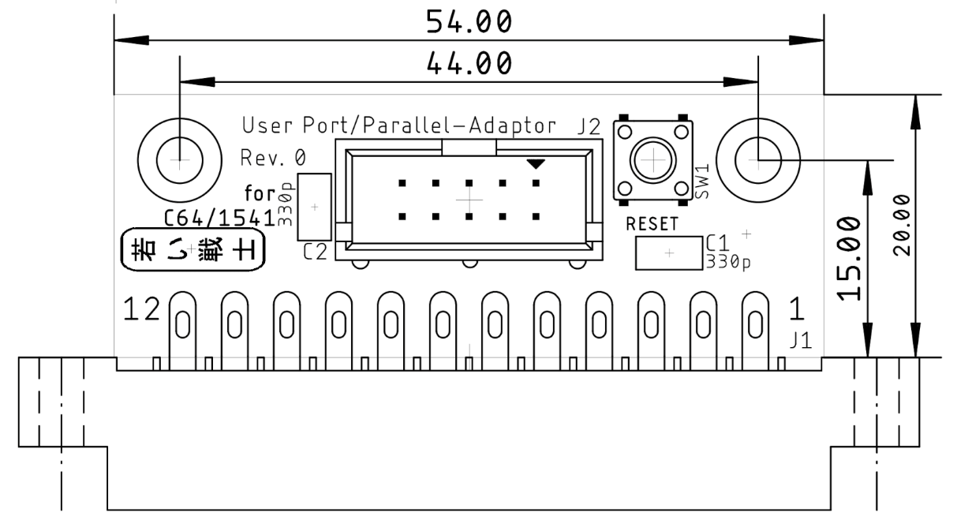

Figure 3: Dimensions of the User Port Parallel Adapter

# Case

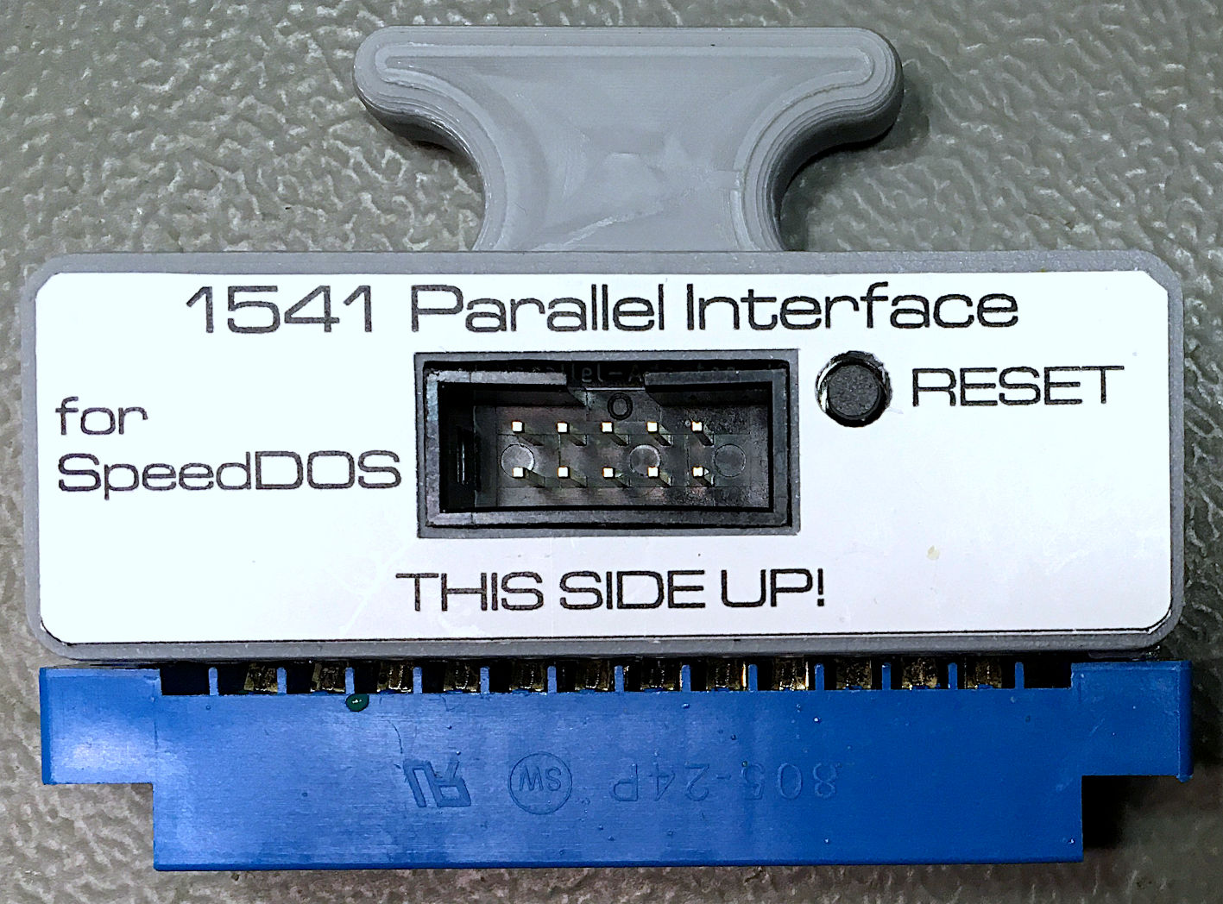

Figure 4: User Port Adapter in a 3D-printed case

# Annotations

SpeedDOS requires a special Software in the 1541 and 1541-II floppy disk drive. While the 1541-II accepts a 27C128 EPROM, the EPROM of the 1541 is a 2364 type, which requires an adapter. The Long Board Kernal Adapter (<https://github.com/svenpetersen1965/C64-Kernal-Adapter-Switch-Long-Board>) can serve this purpose. The height is not critical in the 1541, but installing a vertical pin header instead of a 90° type is recommended.

The cable making is pretty simple. Both ends of the cable are connected to IDC type connectors, which means, a small vice is a sufficient tool for attaching the connectors to the ribbon cable. In case you are not familiar with this work, please consult my article about cable making: <http://tech.guitarsite.de/cable_making.html#Ribbon%20Cables>

# Revision History

## Rev. 0

* Prototype (fully functional)